### **Configuring Webserver On Docker Using AuTomation Tool Ansible !!**



**Task Description:-**

Write an Ansible PlayBook that does the following operations in the managed nodes:

* Configure Docker
* Start and enable Docker services
* Pull the httpd server image from the Docker Hub
* Run the httpd container and expose it to the public
* Copy the html code in /var/www/html directory and start the webserver

**Pre-requisites:-**

* Setup should be ready for performing the above task
* U Should Have Ansible Installed in Controller Node that i have

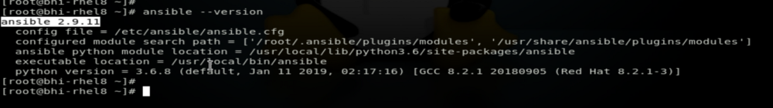

and Complete Explanation Of How to Install Ansible and do the setup ready i have explained it step by step in my previous Article :- [**Ansible Installation .**](https://medium.com/@sabhi8226/ansible-installation-in-rhel-8-be24c9e83baf)

* U must have 2 vm’s One For Controller Node where will install ansible and One For Managed Node means Target Node where we will configure remotely from controller node using ansible

We Need two Systems One Controller Node and One is Managed Node (Target Node .)

So Here is Controller Node Where we have Ansible Installed and we can control target systems from here !!!

IP 192.168.43.178

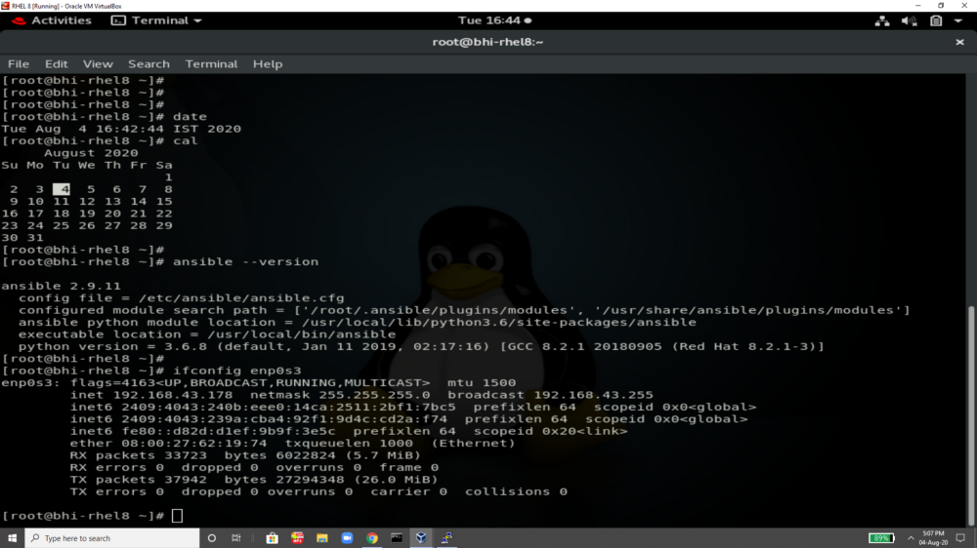

And Here is Our Managed Node (Target system)

IP 192.168.43.253

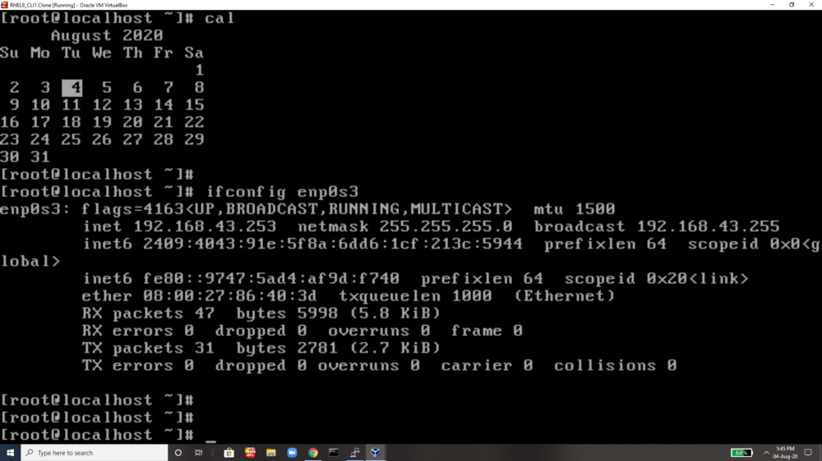

Now EveryThing we will Perform From Our Controller .

For Doing This we can do it from command line using command or we can write ansible playbook so that it will easy to use .

This is the workspace where we will write our playbook and all for this task

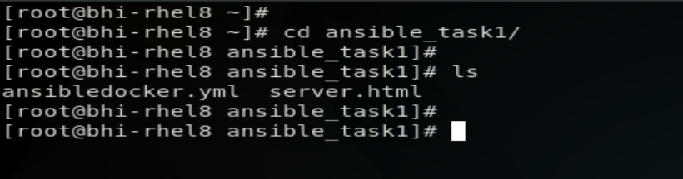

This is our playbook

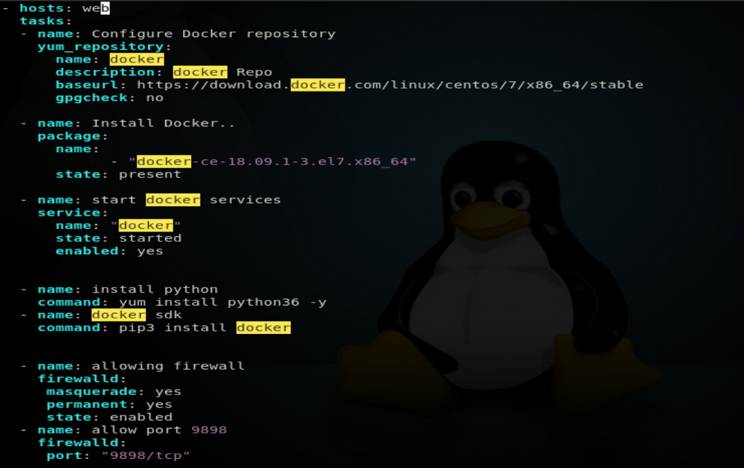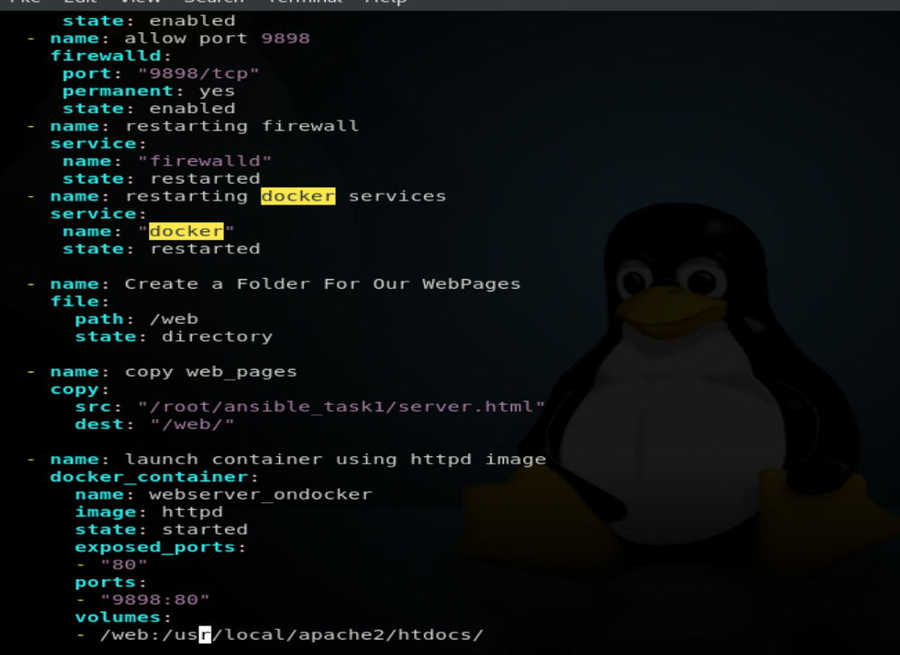

Let me Explain u the code written Inside this playbook

First of all we need to give our managed node (target system) ip , username and password .

we will give it in /etc/myhost.txt file and will give this file name in /etc/ansible/ansible.conf file

/etc/myhosts.txt

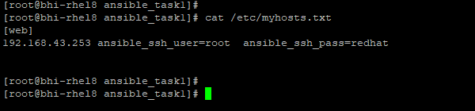

/etc/ansible/ansible.conf

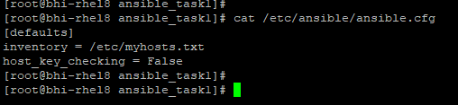

This Code will Configure Docker Repo. For Installing docker-ce

- hosts: web

tasks:

— name: Configure Docker repository

yum_repository:

name: docker

description: docker Repo

baseurl:<https://download.docker.com/linux/centos/7/x86_64/stable>

gpgcheck: no

— — — — — — —

It will Install docker-ce version 18 One of stable version

name: Install Docker..

package:

name:

— “docker-ce-18.09.1–3.el7.x86_64”

state: present

— — — — — — —

Starting Docker Services

name: start docker services

service:

name: “docker”

state: started

enabled: yes

Install Python3 and docker sdk

- name: install python

command: yum install python36 -y

— name: docker sdk

command: pip3 install docker

This will allow Firewall, Enabled Masquerade and will change its , Port 9898 then restart firewall and then restart docker service

- name: allowing firewall

firewalld:

masquerade: yes

permanent: yes

state: enabled

— name: allow port 9898

firewalld:

port: “9898/tcp”

permanent: yes

state: enabled

— name: restarting firewall

service:

name: “firewalld”

state: restarted

— name: restarting docker services

service:

name: “docker”

state: restarted

CreaTe Directory For our webpages so that we can mount it in our container afterward .

- name: Create a Folder For Our WebPages

file:

path: /web

state: directory

I Have Created One WebPage and we can copy inside the directory created above and can do the furthur things.

This is the webpage i created

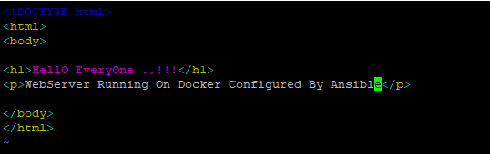

- name: copy web_pages

copy:

src: “/root/ansible_task1/server.html”

dest: “/web/”

It will Launch a Container with httpd image and will mount the directory to the container with the webpage we have .

- name: launch container using httpd image

docker_container:

name: webserver_ondocker

image: httpd

state: started

exposed_ports:

— “80”

ports:

— “9898:80”

volumes:

— /web:/usr/local/apache2/htdocs/

This is the Final Code of Ansible playbook that will do everything for us mentioned in task description .

- hosts: web

tasks:

— name: Configure Docker repository

yum_repository:

name: docker

description: docker Repo

baseurl:<https://download.docker.com/linux/centos/7/x86_64/stable>

gpgcheck: no

- name: Install Docker..

package:

name:

— “docker-ce-18.09.1–3.el7.x86_64”

state: present

- name: start docker services

service:

name: “docker”

state: started

enabled: yes

- name: install python

command: yum install python36 -y

— name: docker sdk

command: pip3 install docker

- name: allowing firewall

firewalld:

masquerade: yes

permanent: yes

state: enabled

— name: allow port 9898

firewalld:

port: “9898/tcp”

permanent: yes

state: enabled

— name: restarting firewall

service:

name: “firewalld”

state: restarted

— name: restarting docker services

service:

name: “docker”

state: restarted

- name: Create a Folder For Our WebPages

file:

path: /web

state: directory

- name: copy web_pages

copy:

src: “/root/ansible_task1/server.html”

dest: “/web/”

- name: launch container using httpd image

docker_container:

name: webserver_ondocker

image: httpd

state: started

exposed_ports:

— “80”

ports:

— “9898:80”

volumes:

— /web:/usr/local/apache2/htdocs/

Now we can run our playbook to configure everything but few things we should check before doing this and this is good practice .

To Check Connectivity between Controller Node and Managed Node(Target System) By pinging them .

ansible all -m ping

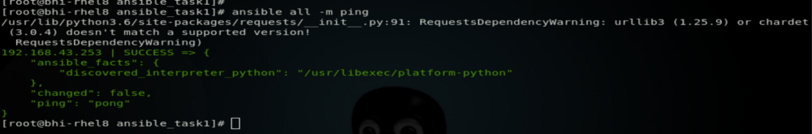

Now cheking in Target system . Docker repo is not there and docker is not installed .

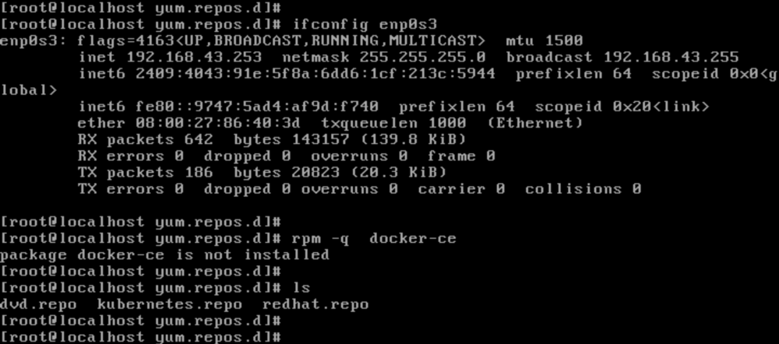

THis is final command that will run our ansible playbook and will configure everything .

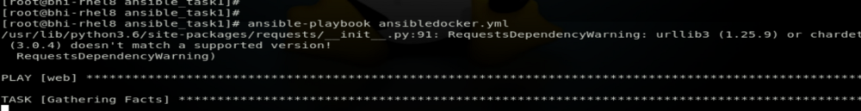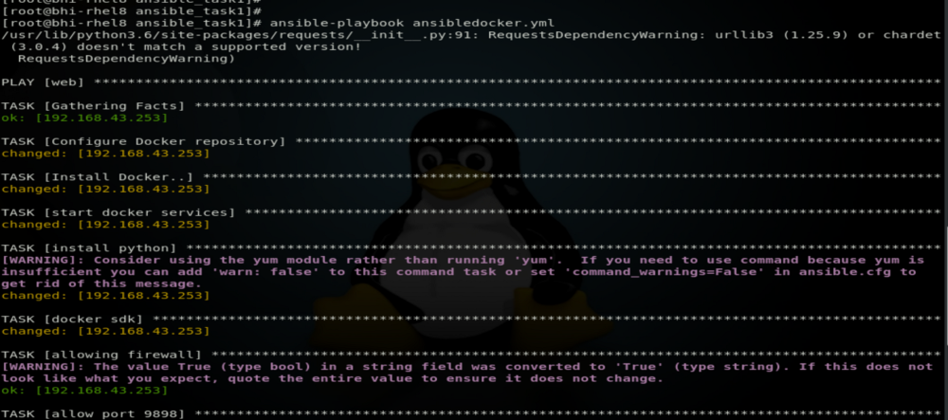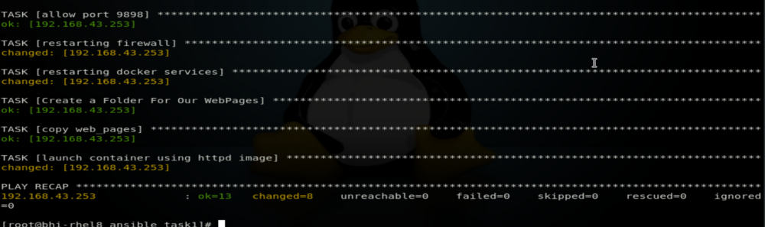

Now Ansible Playbook has comleted it work and now we can see the output on Managed system side .

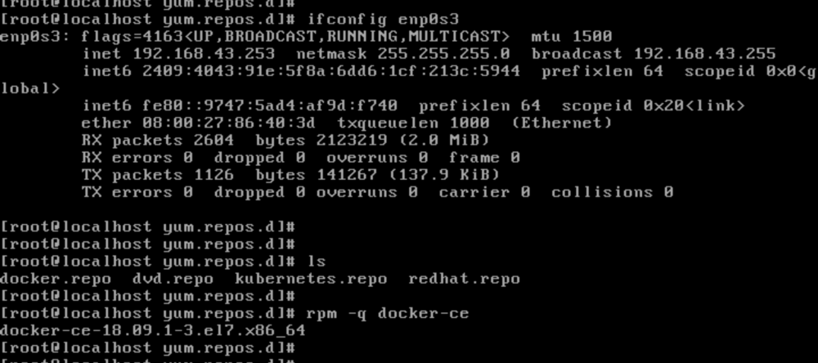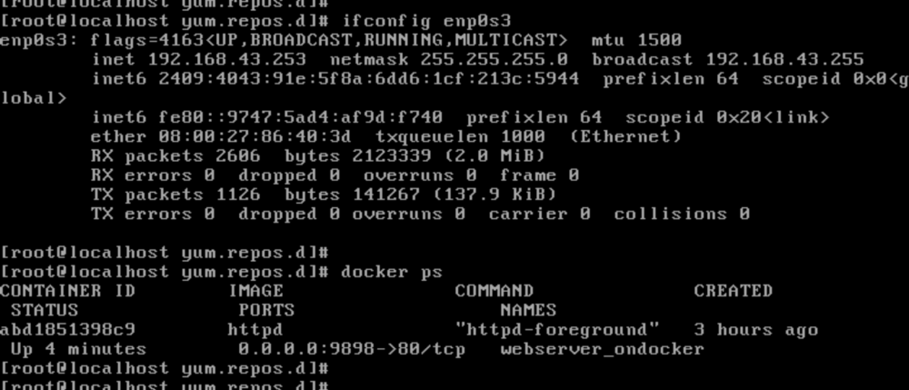

docker container is launched and now we can see its output in browser

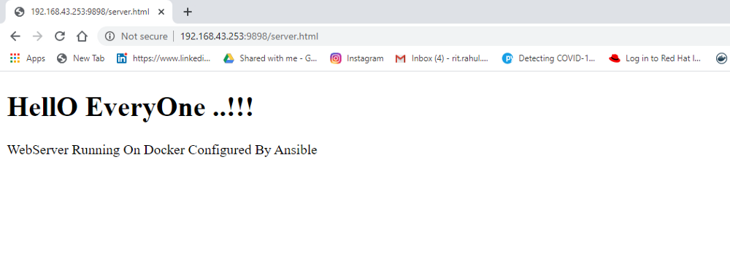

Thats All its Done Configuring Webserver On Docker Using Ansible. !!